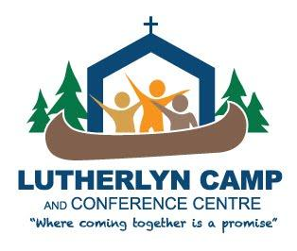

LUTHERLYN
CORPORATION
MEMBERSHIP FORM 2019

Name: _______________________________________

Address: ____________________________________________

Telephone:________________________ Email: ___________________________
I expect to attend the AGM on June 22, 2019 □ YES □ NO
____________________________________________________________________________

Lutherlyn needs your help to continue to grow; to continue to be a place where life-long memories
are made; where Christian Education is offered for people of all ages, where children are free to experience Christ our Saviour in a safe nurturing environment, and where the community gathers for retreat, nurture and renewal.

Yes, I would like to become a member of the Lutherlyn Camp and Conference Centre Corporation. I recognize and support the mission and values of the Lutherlyn Camp and Conference Centre and understand my membership must be approved by the Board.
$20.00 (renewed annually)

Cheques payable to: Lutherlyn Camp and Conference Centre
can be mailed to: PO Box 531, Stn. Main, Pembroke, ON, K8A 6X7

Thank you for your support.

_ _ _ _ _ _ _ _ _ _ _ _ _ _ _ _ _ _ _ _ _ _ _ _ __ _ _ _ _ _ _ _ _ _ _ _ _ _ _ _ _ _ _ _ _ _ _ _ _ _ _ _ _ _ _ _ _ _ _ _ _ _ _ _ _ _ _ _ _ _ _ __ _

RETAIN FOR YOUR RECORDS and post on your fridge until the AGM

LUTHERLYN CAMP AND CONFERENCE CENTRE
CORPORATION MEMBERSHIP 2019

$20 ANNUAL FEE PAID cheque# _______
date____________________

2019 CORPORATION ANNUAL MEETING:

SATURDAY JUNE 22, 2018 10:00 for registration, meeting begins at 10:30

Schmieder Hall, Lutherlyn Camp
909 Zadow Road, Golden Lake, ON
LIGHT LUNCH PROVIDED

